**Assignment – 5**

1. **Link:** [Click Me!](https://people.rit.edu/ss5765/Assignment%205/Final.html)
2. The tool consists of three interactive visualizations, which hold the data for the Agricultural Land for the countries Argentina, India, Malaysia, and France over the decade of 1996-2016. The first Map holds information about the Agriculture Land for the year 2009. The next visualization plots all the percentage of land with respect to the countries and the respective year.
3. One of the interesting patterns found from the piece of data in countries like Argentina and India, the economy is based on agriculture, food, and Species. France and Malaysia's economy is based on more technological and energy sectors. The year 2009 showed that the percentage of the land was decreasing tremendously in France approximately 53% of the land, as seen in the line chart that cuts the line for Argentina.

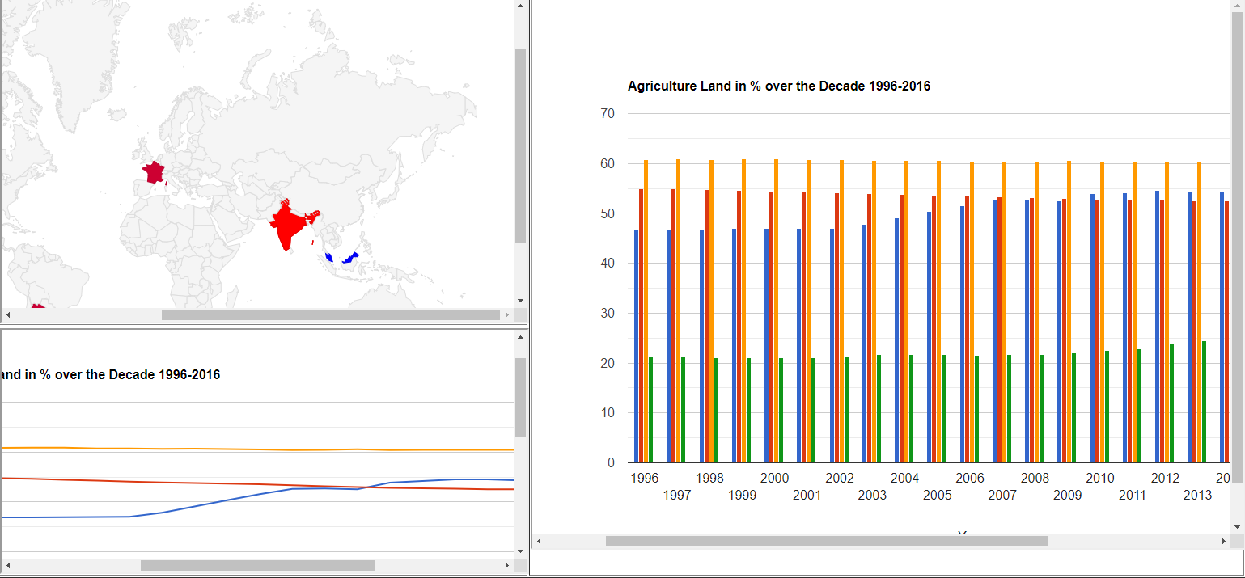

1. Pathfinding on the map was in my mind for the generation of heatmap on the map, going from blue to red in the year 2009. The pattern is based on the line chart that cuts for France. The other algorithm that helped was brushing as there are 10 years displayed its hard to analyze. Thus it helps to relate information patterns from a histogram.
2. Given more time to implement the study of d3 js, implement small pattern comparisons in large information space based on the data to carry out important decisions and planning.

**Comments:**

For Some reason it was hard to implement the D3 javascript on one of the charts, I even tried to study from scratch but it was really lengthy and time was less. Implementation of the one of my files didn’t gave in output, the data input of CSV was working but the required output was not executable.